Release Assembly - TopCoder Security Groups Release 7 version 1.0
Deployment Guide

Revision History
Author | Revision Number | Date
TCSASSEMBLER | 1.0 | Mays – 15th - 2013

Deployment Instructions 3
1. Organization of Submission 3
2. Application Setup 3
2.1 Ant .Properties File 3
2.2 Build Scripts Setup 3
3. Database Setup 4
3.1 Queries setup 4
3.2 Test Data Setup 4
4. Deployment Instructions 4
4.1 Deploy Direct 4
5. Starting 4
6. Verification 5
6.1 Test Group Project Permission with user : wyzmo 8
6.2 Test Group Billing Account Permission with user : ksmith 12
7. Resource Contact List 12

Deployment Instructions

Organization of Submission

The content of submission follows directory structure provided below:

direct

Contains the sources and configuration of the cockpit application in this assembly

doc

Contains this document which is the deployment guide for this assembly.

test_files
This folder contains the test files for this assembly, they will be used to verify the assembly.

db
This folder contains updated DB scripts for DB trunks. These files are commit-ready.

Application Setup

The application is expected to be deployed to the following environment:

- JRE 1.5
- JBoss 4.2 GA
- Informix DS 11.0
- MySQL 5.x

Ant .Properties File
No changes were performed regarding Ant .Properties file.

Build Scripts Setup
The ANT build script for Direct application (build.xml) provides the following targets which are to be used:

- switch-and-checkout – checkout or switch to the defined source code branches for all components defined in subprojects.xml
- dist-backend – rebuilt all the components from the source code.
- first_deploy – must be the first task to execute from command line. It will copy all dependencies to your local JBoss folder.
- deploy – should be the main task to execute from command line. It will build and deploy WAR file.
- deploy-static-files – deploys the static files to JBOSS.
- deploy-apache-static – deploys the static files to apache server on VM.

Please refer here for more information:
http://www.topcoder.com/wiki/display/docs/TC+Direct+Setup+Guide

Database Setup

Queries setup
Because there are many queries to be added. It’s recommended to reinstall the database to setup the new queries. The easiest approach is

- Setup db via informix account (for details on VM see http://www.topcoder.com/wiki/display/docs/VM+Image+2.5 ). (Recommended)

  - Login into vm as informix account, you may need to login as direct account then execute “su informix -l”, the password is 1nf0rm1x
  - Copy db/* to /home/informix/scripts/, overwrite existing files.
- Note: You’d better use the revision 83222. If you scripts folder is not in this revision, you can run ‘svn up –r 83222’ to update it to before overwriting.
  - Execute “cd /home/informix/scripts”
  - Execute “ant drop_db”
  - Execute “ant setup_db”

You can also copy db/* to /home/informix/scripts/, overwrite existing files and use test_files/insert_new_commands_and_queries.sql to insert the new commands and queries records. And then run ‘ant query_catalog’ to load the new quries.

Test Data Setup

Insert test data

You need to execute test_files/testdata.sql against the Informix database to insert projects and contests test data.

Deployment Instructions

Deploy Direct
- Login as direct
- Merge the direct dir in the submission folder to the /home/direct/direct folder on the VM
- Go to game_plan_service folder and run ‘ant dist_tcs’ to rebuild and redeploy the updated component.
- Build and deploy Direct application using ant deploy (or ant first_deploy ) command.
- Copy static files using ant deploy-static-files command or ant deploy-apache-static if use apache as static file server.

Starting
Cockpit backend and Direct need to be started for this assembly.

Verification
Go to http://cockpit.cloud.topcoder.com/direct/ and login as heffan with password ‘password’

First we go to the project edit to check what users have permission on this project: Client 50001 Billing Account 1 Project 1

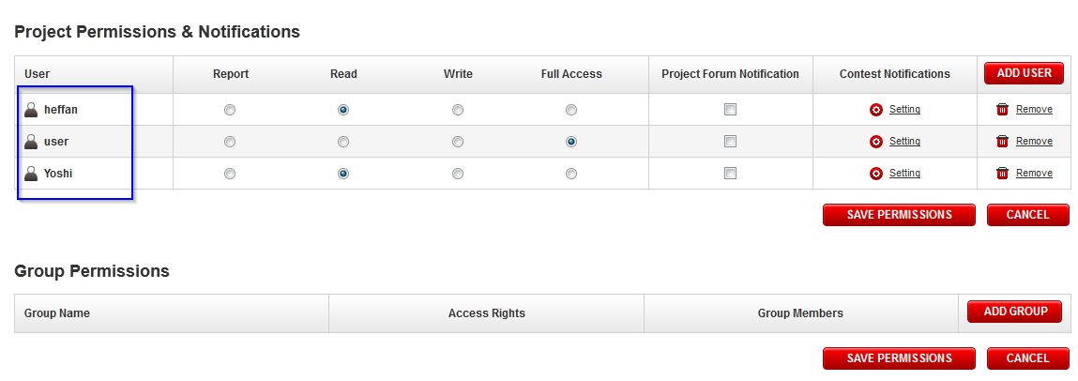

We need to setup two new groups to give two users who do not have project permissions on Project “Client 50001 Billing Account 1 Project 1” to test the group permissions:
(1) A new group gives user wyzmo group project permission on “Client 50001 Billing Account 1 Project 1”, the setup is like this
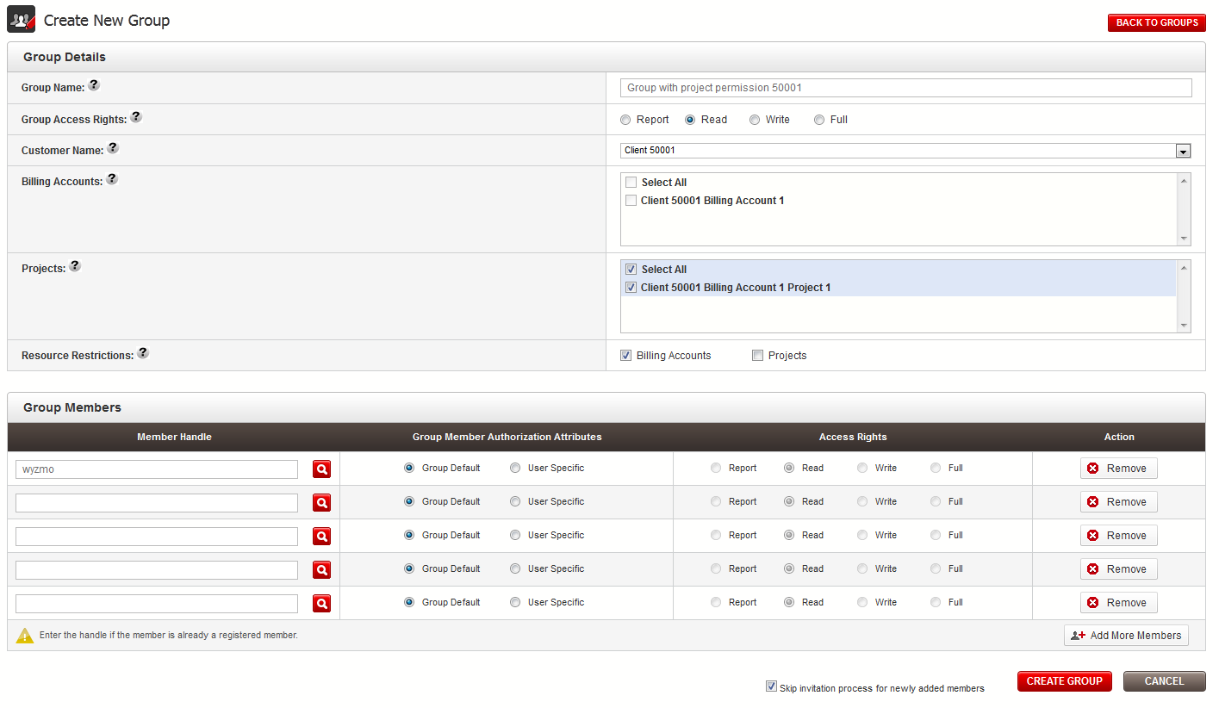

(2) A new group gives user ksmith group billing account permission on billing account “Client 50001 Billing Account 1”, the setup is like this

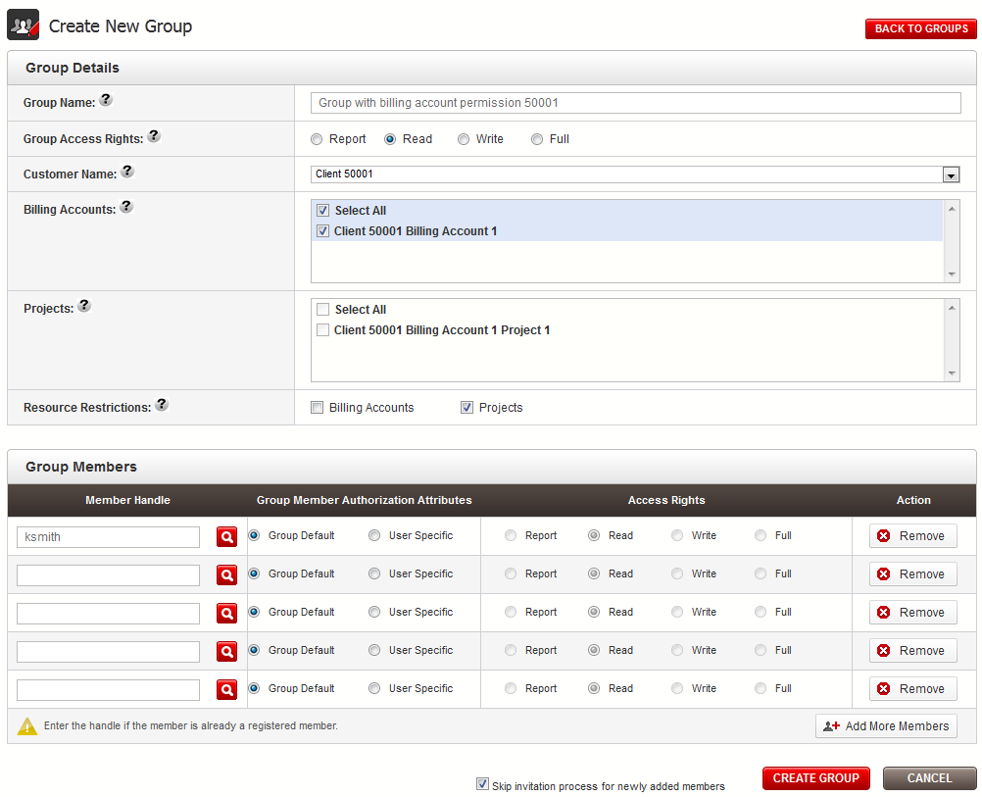

After setup two groups, you can see
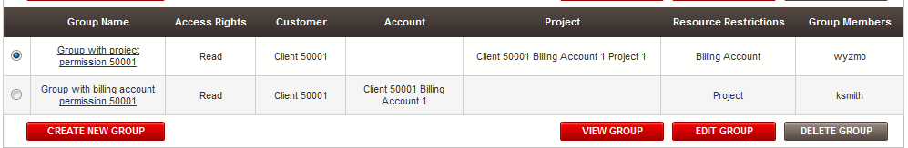

Login as the ‘user’ which has TC account group to invoice some payment records
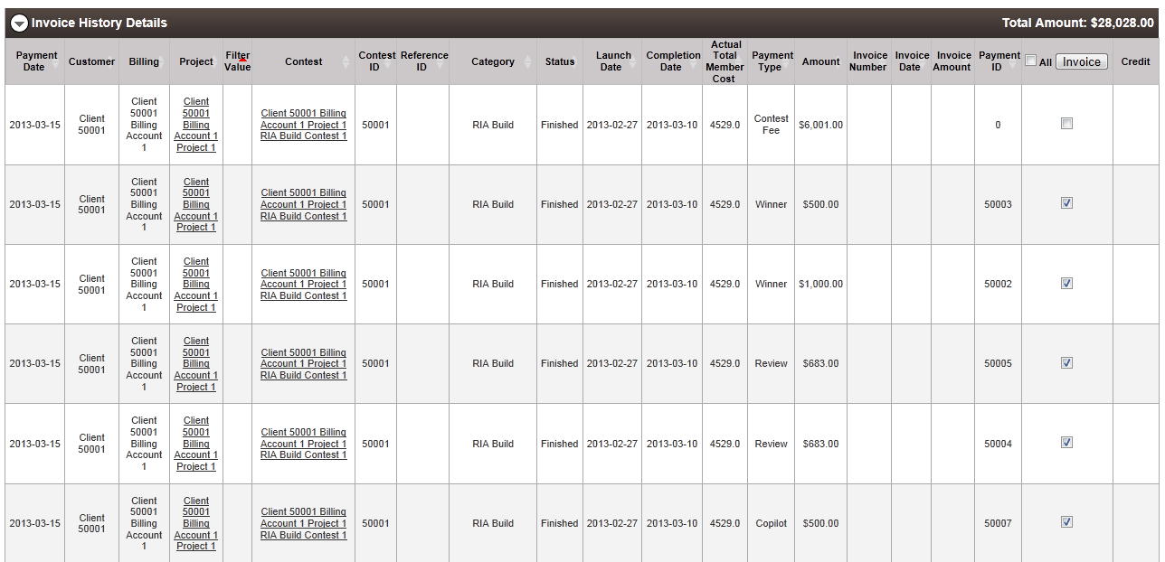

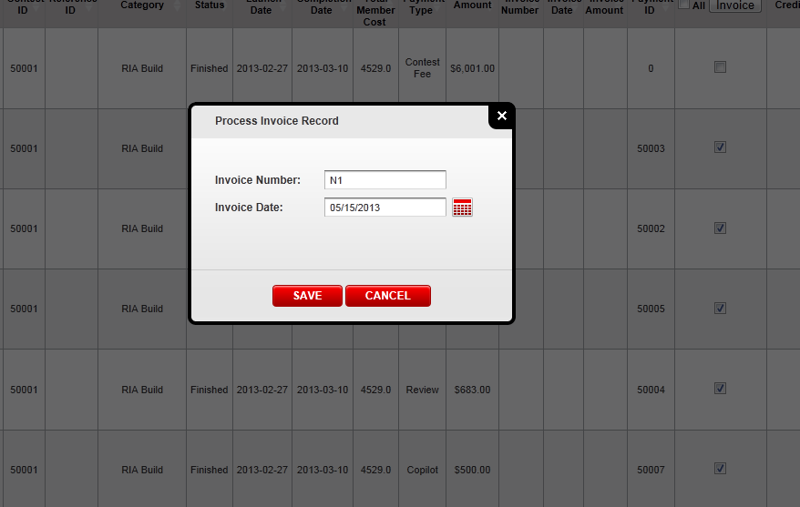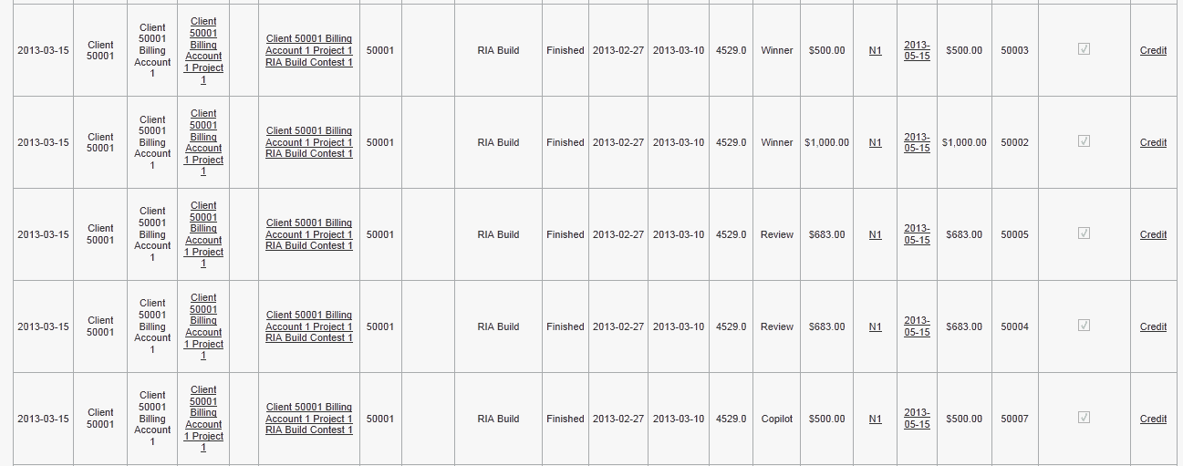

Test Group Project Permission with user : wyzmo
Login as user wyzmo into the cockpit, the password is ‘password’

Check Invoice Report without invoice number
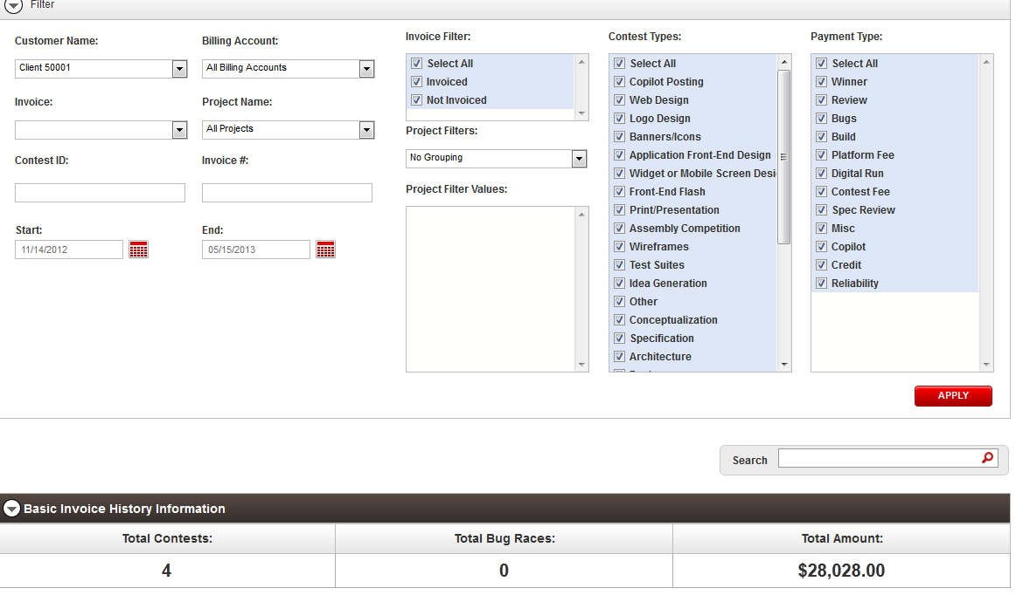
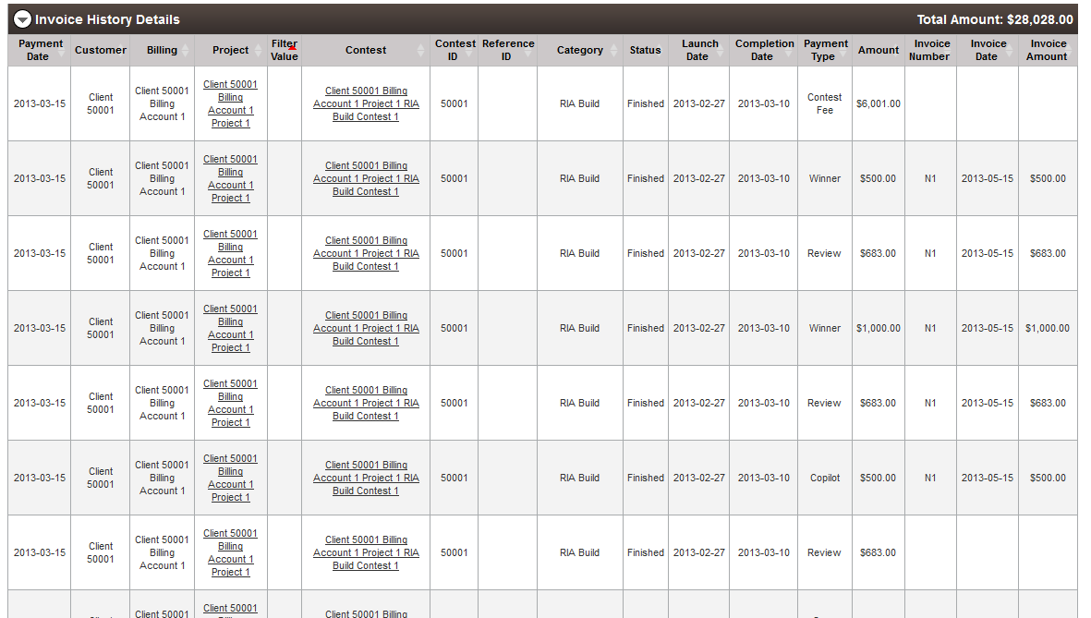

Check invoice report with invoice number
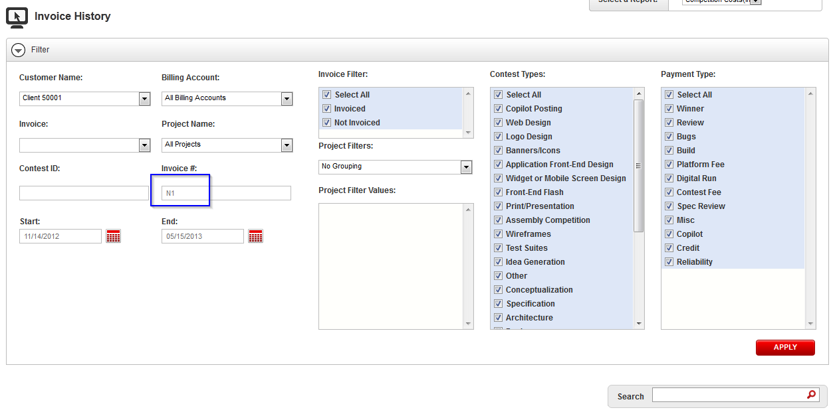
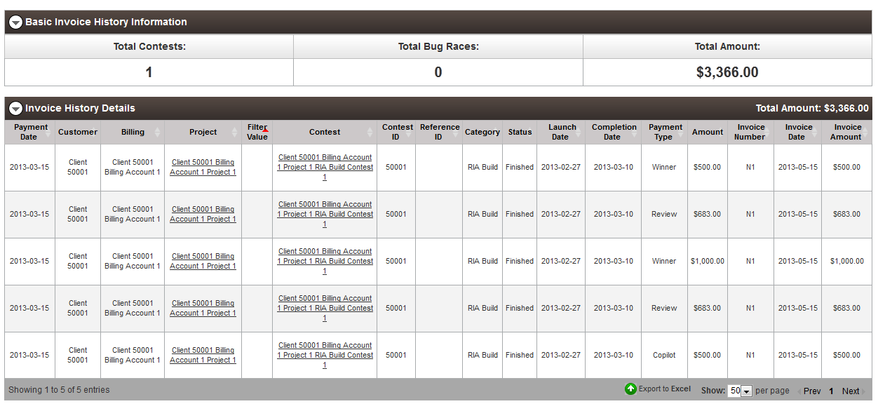

Check project overview page
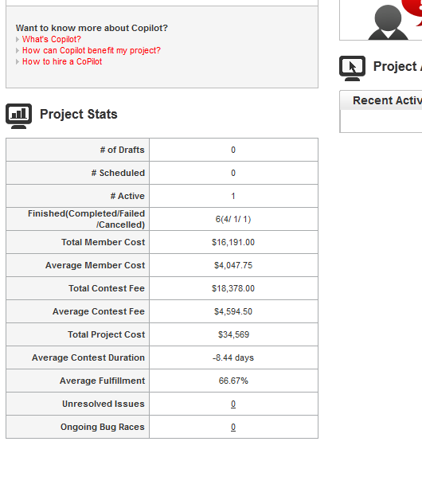

Check the project game plan page

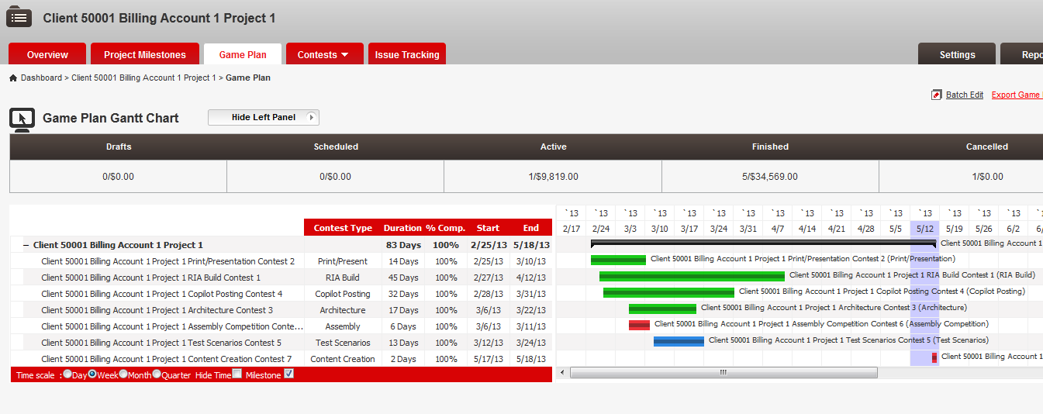

Test Group Billing Account Permission with user : ksmith
Login as user ksmith into the cockpit, the password is ‘password’

Use exact the same test steps as verification 6.1

Resource Contact List
Name | Resource Email
TCSASSEMBLER

